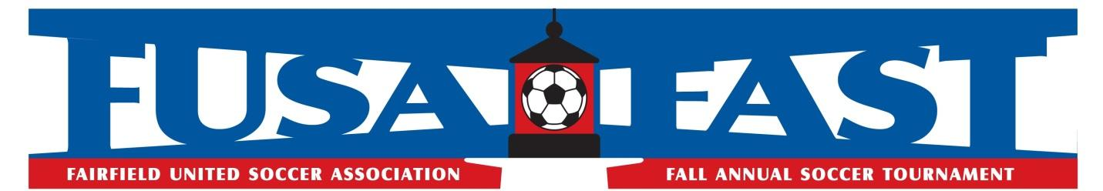
Team Medical Form
Release of Liability and Consent for Medical Treatment

To: Fairfield United FAST Soccer Tournament
Subject: Release of liability and indemnification and consent for emergency medical aid and treatment

Team Name _________________________________ Town _______________________________
Age/Division _____________________

I, the parent or guardian of the below named participant, hereby give my permission and approval for his/her participation in the FAST tournament. In consideration for being permitted to play in the FAST Soccer Tournament, I HEREBY RELEASE, WAIVE, DISCHARGE AND COVENANT NOT TO SUE the Fairfield United Soccer Association, the Town of Fairfield, and and all Town of Fairfield boards, organizations or officials, the promoters, organizers, sponsors, supervisors, volunteers, members, officials, agents, servants, or employees of the event FROM ANY AND ALL LIABILITY TO THE UNDERSIGNED, his personal representatives, assigns, heirs, and next of kin FOR ANY AND ALL LOSS OR DAMAGE, AND ANY CLAIM OR DEMANDS THEREFORE ON ACCOUNT OF INJURY TO THE PERSON OR PROPERTY OR RESULTING IN DEATH OF THE UNDERSIGNED ARISING OUT OF OR IN ANY WAY RELATED TO THE EVENT(S), WHETHER CAUSED BY THE NEGLIGENCE OF THE RELEASEES OR OTHERWISE. I understand and appreciate the risks inherent in the game of soccer and, on behalf of the below named participant, agree to assume all risks and hazards incidental to such participation in the FAST Tournament. I understand and acknowledge that I have carefully and thoroughly reviewed the terms of this release and have signed it freely and without any pressure of duress. I further acknowledge that by signing this release I give permission and assume financial responsibility for the treatment and care of my child for any injury, sickness, or condition requiring medical treatment or medical attention during said activities.

Player’s Name | Parent’s Signature | Telephone Number | Date

